**BODY SAFETY: EMPOWERING YOUR KIDS THROUGH CONVERSATION**

**A FREE event for adults who want to learn more about sexual abuse prevention**

**Tuesday May 31st 2016  
Quispamsis Qplex**

**6:30pm – 8:00pm**

**PRESENTED IN PARTNERSHIP BY :**

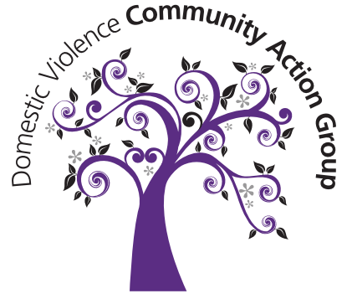



1) Why is it important to talk to children about their bodies?  
2) How do we start these conversations?  
3) How can we spot child predators that are among us every day?  
4) Who benefits from becoming educated about sexual abuse prevention?

Jessica Lanigan, a survivor of child sexual abuse and Founder of Project Roar, will use her experiences to educate you about ways to spot, detect and prevent sexual abuse. We want to shift from a society of silence, to one that **Roars**!

When we teach children about their bodies and how to protect them, we provide necessary knowledge to help them recognize danger, and give them proper vocabulary to communicate if something has happened.   
  
When we educate ourselves about sexual abuse awareness and prevention, sexual offenders feel uneasy. The more we know, **the less power child predators have** over our children**.**

