|  |  |  |  |  |
| --- | --- | --- | --- | --- |
| Hoodie*  $50 | Dri Fit Shirt  $20 | Shorts  $25 | Clinch Bag  $20 | Soft Shell Jacket $50 |

|  |
| --- |
| ***Cash Only*** |

|  |
| --- |
| All items EXCEPT t-shirts (Dri fit & House colour) will have name embroidered. |

|  |
| --- |
| Name for Embroidery |

|  |
| --- |
| House Colour T-Shirts  Purple, Green, Yellow, Blue  $12 |

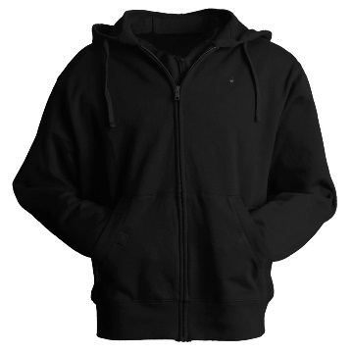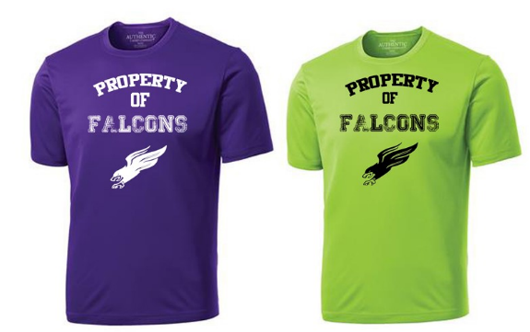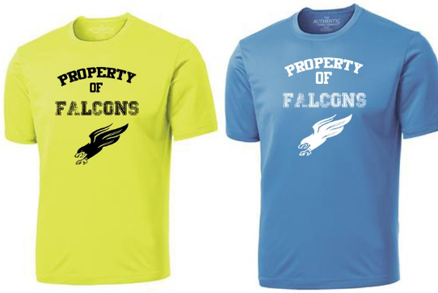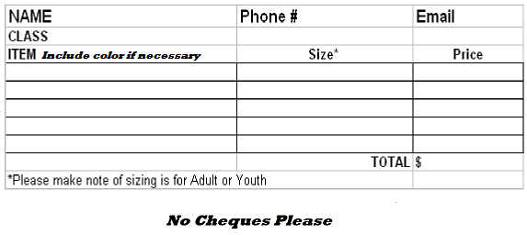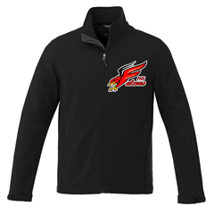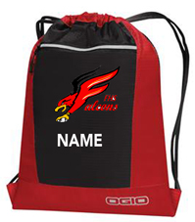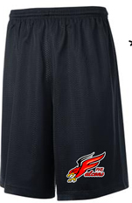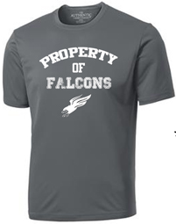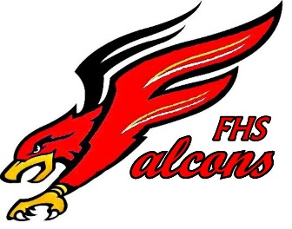

***Hoodies come in full zipper or pull over style. Black or Red Please indicate style on order form below.