Go to office.com, click sign in
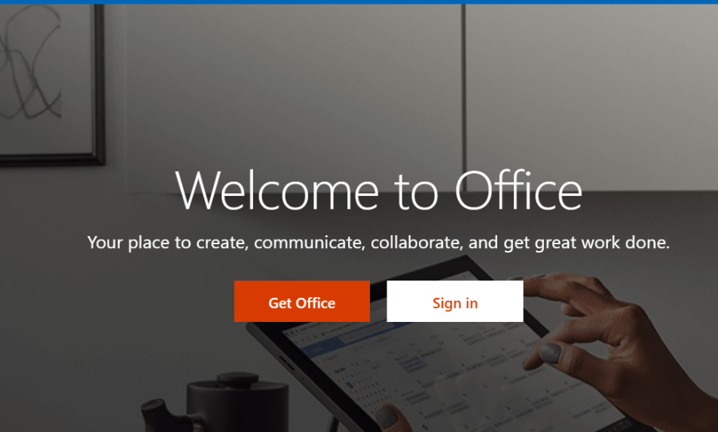

Enter the log in information you use to log into the computers at school. Ex. Andcon1234@nbss.nbed.nb.ca. Do not choose create account, you already have one.
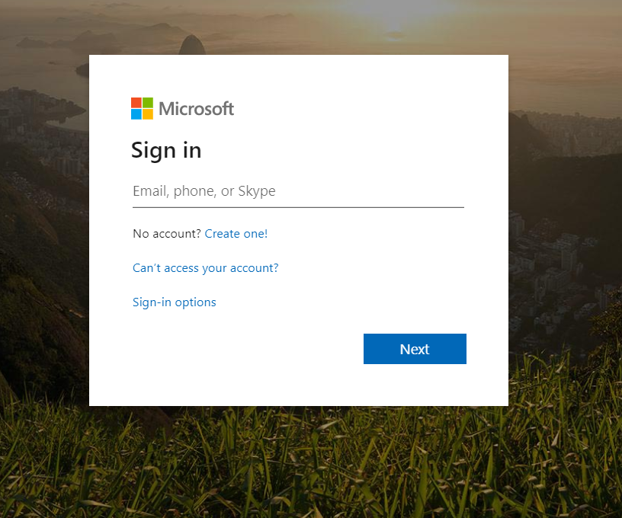

Choose work or school account.

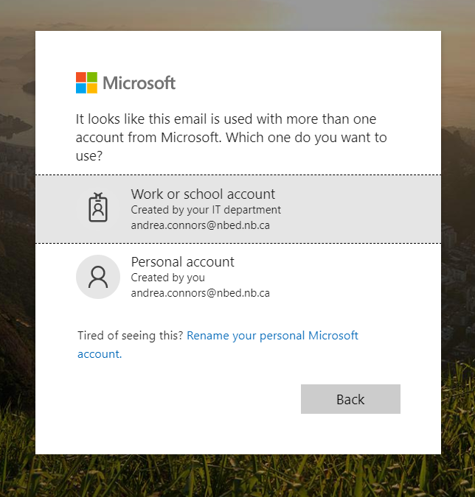
You may be asked to put in your log in information in again if it’s your first time logging in. You will be taken to this screen
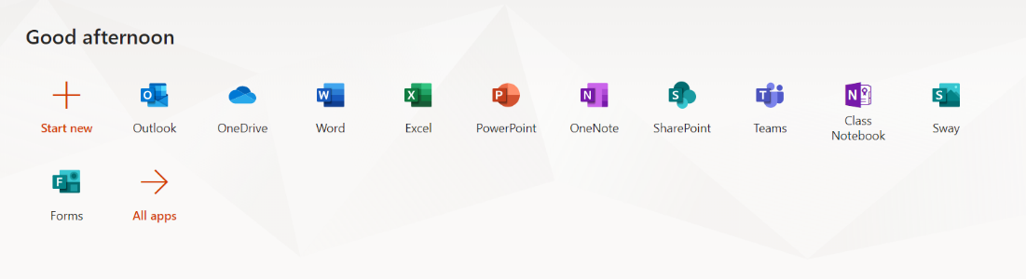

Once you go into teams, you will see your classes listed. Enter the team you are looking to access.

