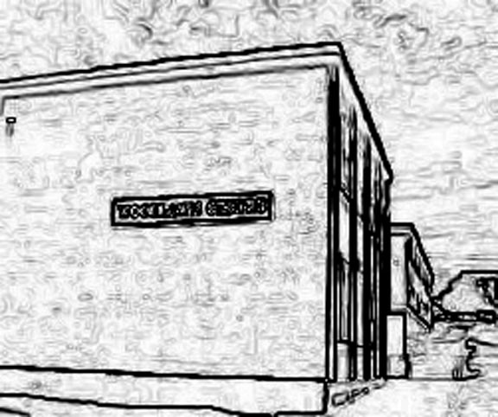

Principal
Mr. B. Hanson

Woodlawn
55 Westmorland Road
Saint John, NB E2J 2E3
Telephone (506) 643-6190
www.woodlawn@nbed.nb.ca
Learning Centre
NEWSLETTER
September 13, 2017

PRINICPAL’S MESSAGE:
Welcome new and former students to the 2017-2018 school year! There are many events taking place this year, and I am looking forward to sending a monthly newsletter to keep everyone informed. Also, we are in the process of updating our web page. New events and information can be found on our site at www.woodlawn@nbed.nb.ca.
Also, please do not hesitate to call us at 643-6190 if you have any questions or concerns.

SCHOOL CALENDAR 2017-2018:
Please make note that there are new additions to the school calendar. The Ministry for Education and Early Childhood Development has initiated changes for teacher professional learning. The following Wednesdays will be a noon dismissal so that teachers can develop professionally: September 20th, October 25th, December 6th, January 17th, and April 25th. The Province will also be introducing Family Day on February 19th, 2018. Please note: Our first half-day is Wednesday, September 20th.

OPEN HOUSE:
Please be reminded that we are having an open house, September 14th between 6:00 pm and 7:30pm. All are invited.

STUDENT FEE:
Student fees are due. The fee is $20 for the year.

SCHOOL TRIP TO IMPERIAL THEATRE:
Our students will be travelling by school bus to see a show at the Imperial Theatre titled, Canada, it’s Complicated” on Friday morning, September 22, 2017. A permission form has been sent home.

DOWNEY FORD & FORD CANADA FUNDRAISER:
Downey Ford and Ford Canada are pleased to support our PALS Schools in a fundraiser taking place on Saturday, September 30th, 9 am -2 pm at Downey Ford. This is an opportunity to raise money for Woodlawn Learning Centre. All we need are participants to test drive a vehicle from Downey Ford and earn $20/test drive for our school. Here’s your chance to test drive one of the following vehicles and raise $ for Woodlawn:
Ford Focus Ford Fusion Ford Explorer Ford Fiesta Ford Escape Ford F150 Ford Edge

Save time and pre-register at https://forddrive4ur.ca/en/partnersassistinglocalschools2017!!!
*We will be sending an RSVP for test driver’s to sign up closer to the date.

WOODLAWN CELEBRATES
A big thank you to Port City Authority for their generous donation of breakfast food items for our students!
Thank you to PALS for their donation of school supplies. Last, but not least, thank you to McDonald’s Restaurant, Main Street, who has once again generously donated meal coupons for us to use as a reward for reinforcing good attendance and/or good behavior. We CELEBRATE you all!

BROWN BAG LUNCHES
Our brown bag lunch program will begin next week on Monday, September 18th and will be available each Monday, Wednesday, and Friday for those in need. This program is provided by the generosity of the combined ministries of Glen View, Park Avenue, and Silver Falls United Churches. If your son/daughter has any allergies that we are not aware of, please let us know.

ATTENDANCE MATTERS:
With the start of the 2017-2018 school year, the District will be continuing an awareness campaign, “Attendance Matters”. Our Superintendent, Zoe Watson, called for a working group to study student attendance in response to a heightened awareness/concern expressed by administrators, teachers, and District Office personnel, and by members of the PSSCs and the DEC. Being present and on time, impacts positively on learning from Kindergarten to grade 12. Good attendance also helps to build habits that will last a lifetime and transfer to life beyond public education. There is a strong correlation between academic success and good attendance. For more information, check the Anglophone South website (www.asd-s.nbed.nb.ca).

FOOD ALLERGIES:
Please be aware that we have students in our centre with severe allergies to nuts and nut products (peanuts, peanut butter, hazelnuts, walnuts, pecans, cashews, almonds, nut oils, etc.). Any minimal contact with these foods may cause a serious allergic reaction and unconsciousness within a matter of minutes. These allergies may even be life threatening. Please do not send these foods to school.

